Central African Republic

## Respect for rule of law (ROL) data

The data set shows the data on the respect of the rule of law for the country.

## # A tibble: 19 x 5  
## country iso3c date ruleOfLaw ruleOfLawCategory4   
## <chr> <chr> <dbl> <dbl> <chr>   
## 1 Central African Republic CAF 1996 -1.15 ROL highly disrespected  
## 2 Central African Republic CAF 1998 -1.18 ROL highly disrespected  
## 3 Central African Republic CAF 2000 -1.28 ROL highly disrespected  
## 4 Central African Republic CAF 2002 -1.05 ROL highly disrespected  
## 5 Central African Republic CAF 2003 -1.44 ROL highly disrespected  
## 6 Central African Republic CAF 2004 -1.58 ROL highly disrespected  
## 7 Central African Republic CAF 2005 -1.45 ROL highly disrespected  
## 8 Central African Republic CAF 2006 -1.54 ROL highly disrespected  
## 9 Central African Republic CAF 2007 -1.57 ROL highly disrespected  
## 10 Central African Republic CAF 2008 -1.41 ROL highly disrespected  
## 11 Central African Republic CAF 2009 -1.31 ROL highly disrespected  
## 12 Central African Republic CAF 2010 -1.29 ROL highly disrespected  
## 13 Central African Republic CAF 2011 -1.29 ROL highly disrespected  
## 14 Central African Republic CAF 2012 -1.44 ROL highly disrespected  
## 15 Central African Republic CAF 2013 -1.79 ROL highly disrespected  
## 16 Central African Republic CAF 2014 -1.70 ROL highly disrespected  
## 17 Central African Republic CAF 2015 -1.68 ROL highly disrespected  
## 18 Central African Republic CAF 2016 -1.82 ROL highly disrespected  
## 19 Central African Republic CAF 2017 -1.73 ROL highly disrespected

## Respect for rule of law (ROL) trend

The plot shows the trend of the respect for the rule of law for the country.

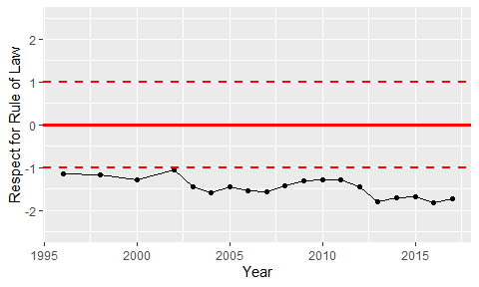

Trend of the Respect for the Rule of Law